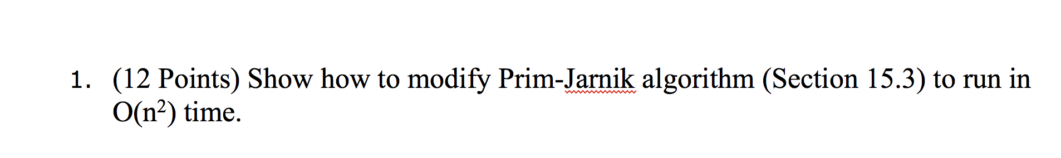
Solution:
The Prim-Jarnik Algo given in the text book is as follows:
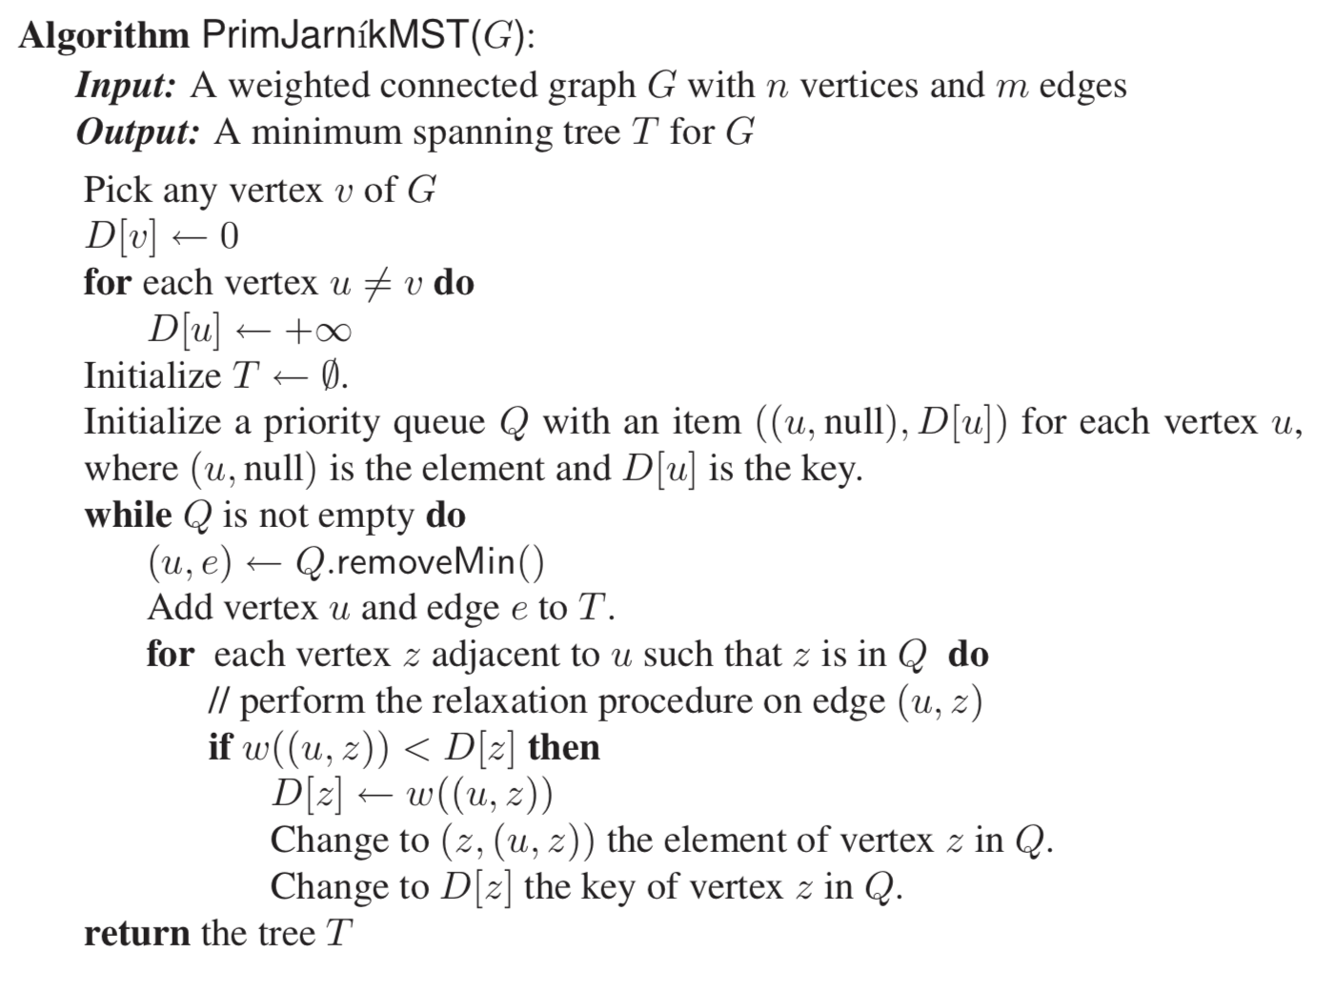
The algorithm can be modified as below:

for each u Vertex of G, do
D[u] = ∞;
π[u] = NIL;
end
D[r] = 0;
Q=V[G];
while Q is not empty, do
u=Q.removeMin()
for each v which belongs to V[G] do
if A[u,v] is not 0 and v ∈ Q and A[u,v] < D [v] then
π[v] = u;
D [v] = A[u, v];
end
end
end

If Graph G = (V, E) is represented as an adjacency matrix, for an vertex u then to find the adjacent vertices, instead of searching the adjacency list, we search the row of u in the adjacency matrix & therefore we assume that the adjacency matrix stores the edge weights, and those unconnected edges have weights 0.

The outer loop (while) has |V | variables and the inner loop (for) has |V | variables.
Hence the algorithm runs in O(V²) or O(n²) in this case.

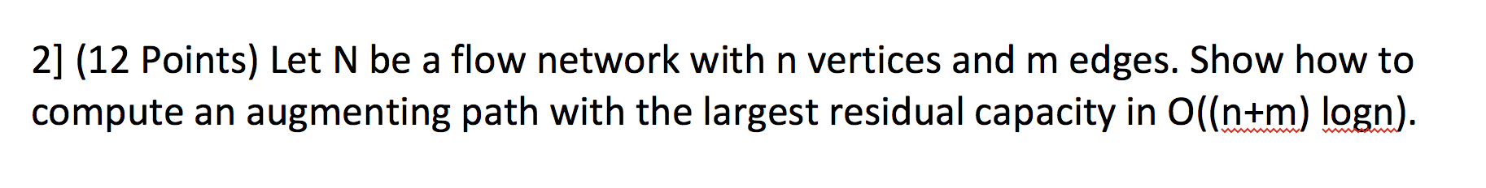
Solution:
To solve the above problem, we modify the Dijkstra’s algorithm.

Algorithm: ModifiedDijkstra_LA _residual_capacity (G, s, t)
Input: A flow net work G, source s and sink t.
Output: The augment path with the largest residual capacity

for all u ∈ G.vertices()
if u  s
D[u]← ∞;
else
D[u]← 0;
P[u] = null;
Let Q be a priority queue that contains all the vertex of G using D labels as keys.
while ¬Q.isEmpty()
u ← Q.removeMax()
for each vertex z such that there is an edged between u and z and z is in Q
if D[z] min(D[u], 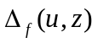) then // where is the residual capacity on the edge from u to z
D[z] ß min(D[u], )
P[z] = “u”;
Change to D[z] the key of z in Q
If (D[t] = =0)
output=“There is no augmenting path”
Else
c=”t”; // where t is the sink
While(c!=null)
output=c+output;
c=P[c];
Return Output

The time complex the same as that of Dijstra’s algorithm, which is O((n+m)logn).

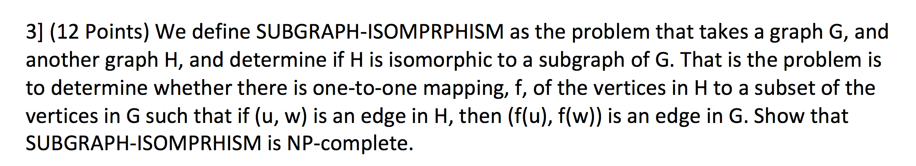
Solution:

SUBGRAPH-ISOMORPHISM is a comparison problem where in two graphs G1 and G2 are there where we need to determine if G1 is subgraph of G2, that is all nodes of G1 is present as subgraph in G2 which is isomorphic.

1] This problem can be further generalized as either CLIQUE problem or HAMILTONIAN-CYCLE problem which are NP-complete.

2] First, we can start performing reduction of G1 using CLIQUE problem & then we get an instance of (G1, k) of clique with n vertices in G1.

3] We then produce subgraph isomorphism (G1, L) where L is complete graph with l vertices and l is minimum of either k or n+1. This reduction runs in polynomial time.

4] Now, if k > n, then (G1, k) is a no instance of clique and hence we didn’t produce any instance of subgraph isomorphism, as we cannot have any graph L in G1 which has only n vertices.

5] Else, it is clear that G1 contains a clique of size k if and only if G1 has a subgraph that is isomorphic to H. As this means same thing.

6] Therefore we have successfully showed that SUBGRAPH-ISOMORPHISM is NP-hard or NP-complete.

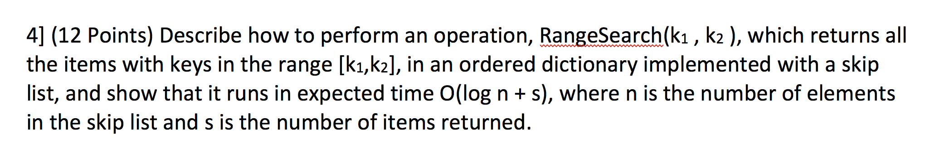
Solution:

Algorithm Skip_Range_Search([k1….k2],skiplist):
Input: Range of values and the skip list
Output: Print all the values in the given range

Let p be the topmost, left node of S (which should have at least 2 levels).
{
while below(p) = null do
{
p ← below(p) // drop down
}
while key(after(p)) ≤ k2 do // Run till the last value in the range
{
Let p ← after(p) // scan forward
If(p>=k1 && p<=k2) // If the values are given in the range then print the value
Print the value of p
}
}

Skip list is a list in which all the elements present are sorted in order, for ease of use.

1] First, we start from the topmost level and drop down to the last level or the level in the skip list.

2] Once it drops down to the last element in the skip list it traverses to the right by calling the after method until we reach the last value given in the range.

3] During traversing the list we check whether they are within the given range if they are specified in the given range then we print the value else we do not print them.
4] The running time of the algorithm is O(log n +s) where n represent the number of elements in the skip list and s represent the number of values it requires to print them.

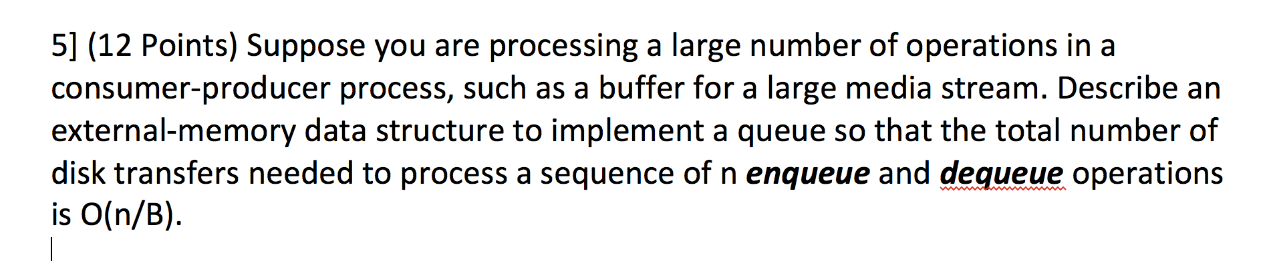

Solution:

Here we use Linked list which will allow the insert and remove operations in O(1) transfers each.
1] In the case mentioned above, every node in the linked list can be considered as a block of data of size B.

2] Queue facilitates the data storage in a sequential manner from head to tail. Initially when the queue is empty head and tail points to the same index i.e 0.

Queue enables us to perform to important operations namely :
• Enqueue
• Dequeue
The Enqueue operation is performed by adding the data at the tail and incrementing the index of the tail by one every time.

3] Similarly, since the queue removes the element on the first come first serve basis, the. Dequeue operation is performed by taking the head index and adding incrementing it too.

4] We can perform the insert operations as we do in the linked list.
To perform the insert operation we first access the last block of the list. If we encounter that the block is empty, we can insert new element in that block and transfer this block back to the disk when we are done.

5] If the block is full, we allocate a new block space and then insert our new element in the list.

6] Similarly, we can remove element from the above list assuming we know which block holds an item to be removed.

7] The operations in the Linked List take O(1) time complexity.

So, for the memory transfer of n operations, the total time complexity will be O(n/B) per operations.

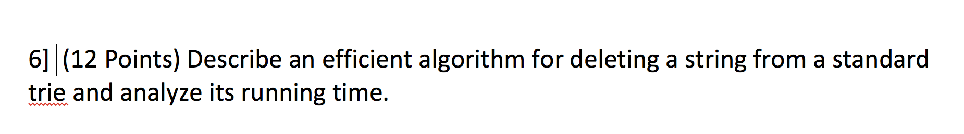
Solution:

Algorithm: DeleteTrieString(T, S):
Input: A trie T from which a string S has to be deleted
Output: A new trie T with string S has been removed

f ← search the standard trie for S
if f then
p ← P.length() // length of S
j ← 0
v ← T.root()
repeat
c ← number of childs of v
if c = 0 then
break
else
for ch in v.childs() do
if S[j] = ch.data() then
delete link of ch from v
v ← ch
j ← j + 1 until T.isExternal(v)
else
print “Error string not in trie”
return T

1] We initially search the string that needs to be deleted in from trie.
2] While traversing down the trie, we reduce the number of Childs counter in each node by 1.
3] When the counter is equal to zero we delete the corresponding nodes all child from memory by traversing.
4] Hence, this algorithm takes O(dm) where m is length of string and d is size of alphabet

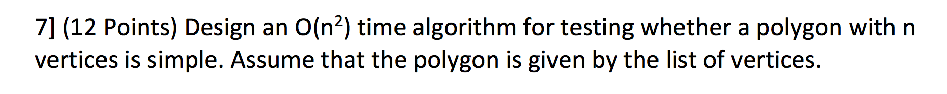
Algorithm: SimplePolygonTest(L):
Input : List L with all vertices of polygon
Output : Whether polygon is simple or not
LL ← new List of pair of end points of line
for p1 in L:
for p2 in L:
if (p1, p2) or (p2, p1) in LL:
continue
else:
If p1 is adjacent to p2 :
LL.insert((p1, p2))
for (p1, p2) in LL: // p1 and p2 are points of a line
for (q1, q2) in LL: // q1 and q2 are points of a line
If ((p1, q1, p2) = CCW and (p1, q1, q2) = CW and (p2, q2, p1) = CW and (p2, q2, q1) = CCW)) OR ((p1, q1, p2) = COLL and (p1, q1, q2) = CW and (p2, q2, p1) = CW and (p2, q2, q1) = CCW)) then
return False
return True

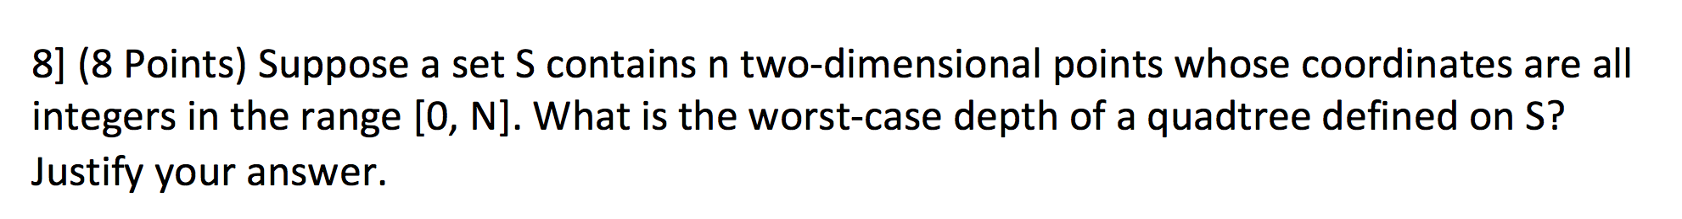
Solution:
The quadtree T is defined by recursively performing a split at each child v of r if necessary.
Every child v of r has a square region Ri associated with it, we check if the region Ri for v contains more than one point of S. If it contains, then we perform a split at v, subdividing Ri into four equal-sized squares and repeating the above subdivision process at v.
Below are the steps to find the worst case depth of quadtree define on S:
1] We start with the root r of T, and we compare the region R for r to A. If A and R, do not intersect at all, then we are done—there are no points in the subtree rooted at r that fall inside A
2] Alternatively, if A completely contains R, then we simply enumerate all the external-node descendants of r.
3] These are two simple cases. If instead R and A intersect, but A does not completely contain R, then we recursively perform this search on each child v of r.
The time complexity for quadtree T for S is O(n) building each level of T.
Thus, in the worst case time complexity depends on the depth of the quadtree which is O(Dn), where D is the depth of the tree.

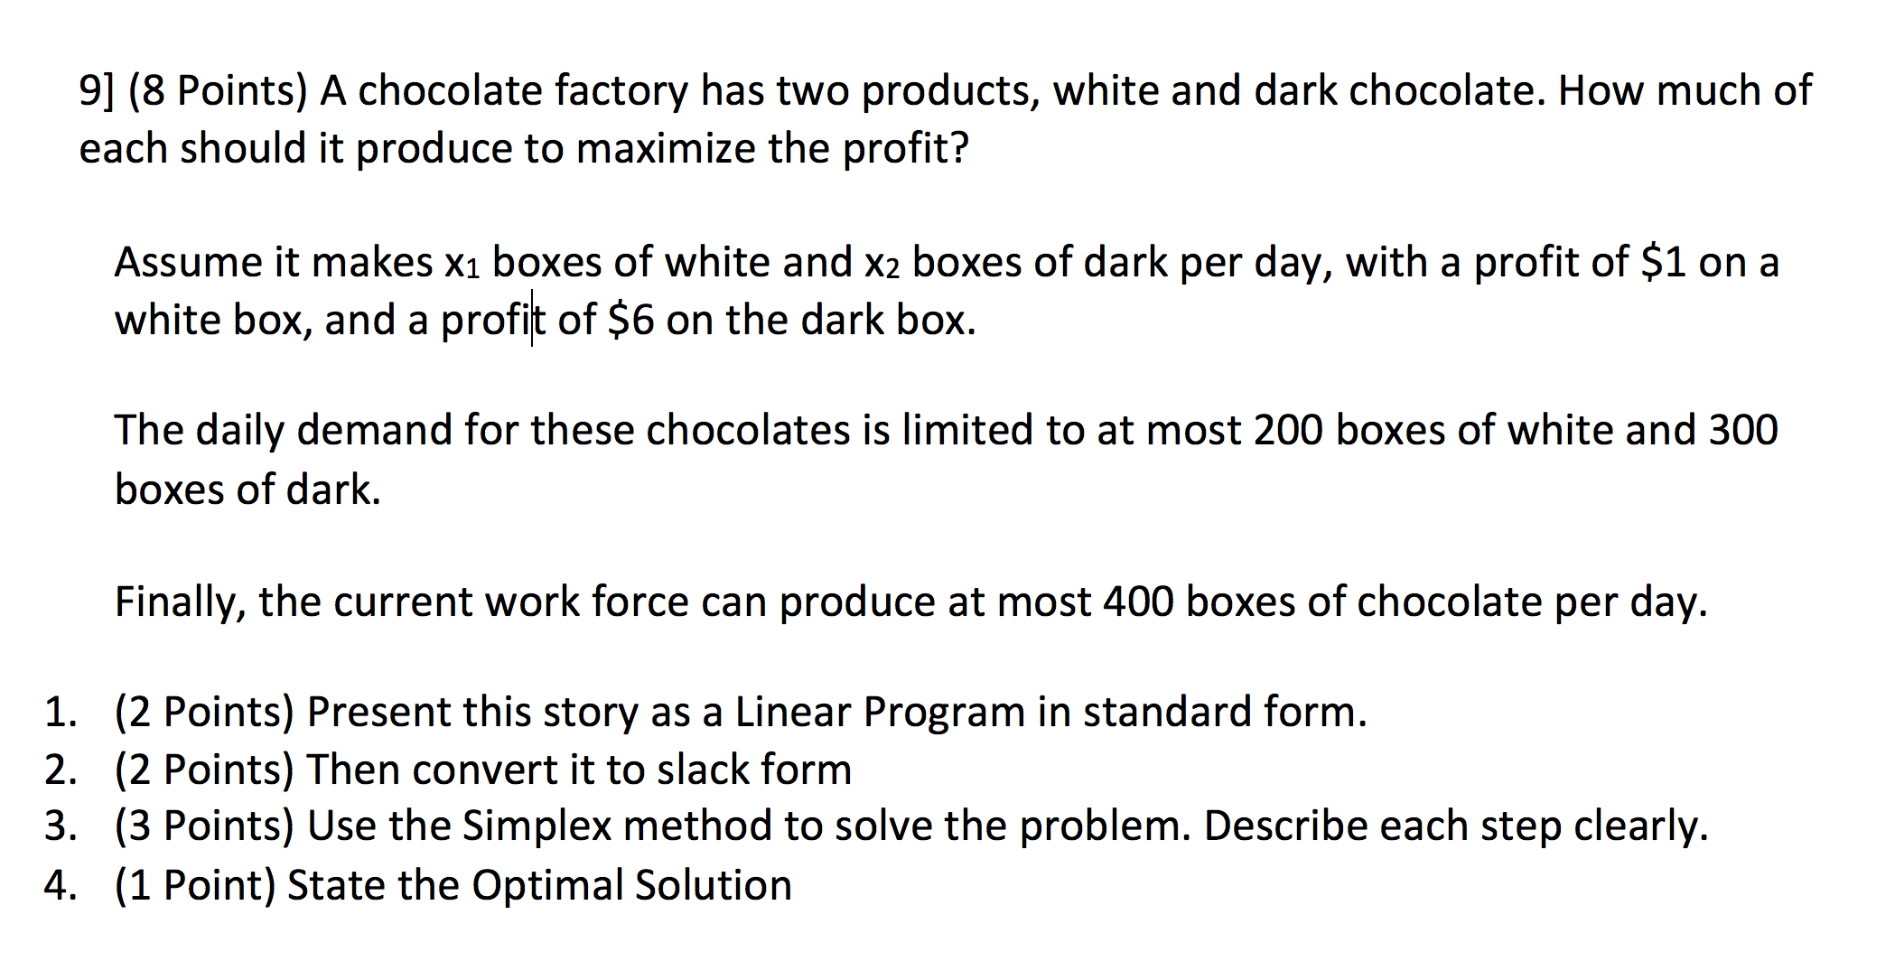1] Optimization Problem is: Maximize: z = x1 + 6x2
Subject to: x1 + x2 ≤ 400
x1 ≤ 200 ; x2 ≤ 300 ; x1, x2 ≥ 0
2] Maximize: z = x1 + 6x2
Subject to:
x3 = 400 – x1 – x2
x4 = 200 – x1
x5 = 300 – x2
x1, x2, x3, x4, x5 ≥ 0
Free Variables: F = {1, 2}
Basic Variables: B = {3, 4, 5}
Basic Solution: (0, 0, 400, 200, 300)
Objective Value: c∗ = 0
3] Let us raise the value of x1. The constraints on x1 are: x1 ≤ 400, x1 ≤ 200 and x1 ≤ ∞. The tightest of these constraints is x1 ≤ 200 coming from the basic variable x4. So we set x1 = 200 and x4 = 0 by pivoting x1 and x4. This yields a new slack
Maximize: z = 200 – x4 + 6x2
Subject to: x3 = 200 + x4 – x2
x1 = 200 – x4
x5 = 300 – x2
x1, x2, x3, x4, x5 ≥ 0
Free Variables: F = {2, 4}
Basic Variables: B = {1, 3, 5}
Basic Solution: (200, 0, 200, 0, 300)
Objective Value: c∗ = 200

Since the coefficient on x4 is negative, raising it from zero will only decrease the objective function. For this reason, we keep x4 fixed at zero and raise x2 until we hit the first constraint. The constraints on x1 are: x2 ≤ 200, x2 ≤ 300 and x2 ≤ ∞. The tightest of these constraints is x2 ≤ 200 coming from the basic variable x3. So we set x2 = 200 and x3 = 0 by pivoting x2 and x3. This yields a new slack
Maximize: z = 1400 + 5x4 – 6x3
Subject to: x2 = 200 + x4 – x3
x1 = 200 – x4
x5 = 100 – x4 + x3
x1, x2, x3, x4, x5 ≥ 0
Free Variables: F = {3, 4}
Basic Variables: B = {1, 2, 5}
Basic Solution: (200, 200, 0, 0, 100)
Objective Value: c∗ = 1400
Since the coefficient on x3 is negative, raising it from zero will only decrease the objective function. For this reason, we keep x3 fixed at zero and raise x4 until we hit the first constraint. The constraints on x4 are: x4 ≤ 200, x4 ≤ 100 and x4 ≤ ∞. The tightest of these constraints is x4 ≤ 100 coming from the basic variable x5. So we set x4 = 100 and x5 = 0 by pivoting x4 and x5. This yields a new slack
Maximize: z = 1900 – 5x5 – x3
Subject to: x2 = 300 – x5
x1 = 100 – x5 – x3
x4 = 100 – x5 + x3
x1, x2, x3, x4, x5 ≥ 0
Free Variables: F = {3, 5}
Basic Variables: B = {1, 2, 4}
Basic Solution: (100, 300, 0, 100, 0)
Objective Value: c∗ = 1900
Now both of the variables in the objective function have negative coefficients, so increasing either of them would decrease the objective function. So we conclude that we must be at the optimum and stop.
4] From the basic solution, we see that x1 = 100, x2 = 300 and c∗ = 190, which is the solution to our original problem.

